**Lab-5 Virtual Function, Polymorphism, and miscellaneous C++ Features**

**1. Write a program to solve the concept of virtual function.**

#include<iostream>

using namespace std;

class base

{

public:

void display ()

{

cout<<”\n display base:”;

}

virtual void show ()

{

count <<”\n show base”;

}

};

class derived: public base

{

public:

void display ()

{

cout<<”\n display derived:”;

}

void show ()

{

cout<<”\n show derived”;

}

};

int main()

{

Base B;

Derived D;

Base *bptr;

cout<<”\n bptr point to base”;

bptr = &B;

bptr → dsplay(); //calls base version

bptr → show(); //calls base version

cout<<”\n bptr points to derived”;

bptr = &D

bptr → display(); // calls base version

bptr → calls derived version

}

**2. Solve the following form of inheritance. [ use virtual base class]**

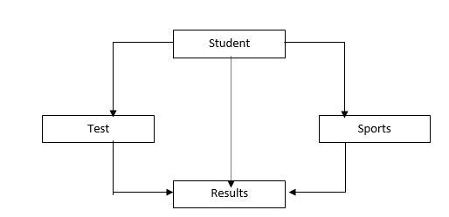

#include<iostream>

using namespace std;

class student

{

protected:

int roll_number;

public:

void get_number(int a)

{

roll_number = a;

}

void put_number(void)

{

cout<<"Roll No:"<<roll_number<<"\n";

}

};

class test: virtual public student

{

protected:

float part1, part2;

public:

void get_marks (float x, float y)

{

part1 = x; part2 = y;

}

void put_marks(void)

{

cout <<"Marks obtained:"<<"\n"

<<"part1 = "<<part1<<"\n"

<<"part2 ="<<part2<<"\n";

}

};

class sports: public virtual student

{

protected:

float score;

public:

void get_score(float s)

{

score = s;

}

void put_score(void)

{

cout<<"sports wt:" <<score<<"\n";

}

};

class result: public test, public sports

{

float total;

public:

void display (void);

};

void result:: display (void)

{

total = part1 + part2 + score;

put_number ();

put_marks ();

put_score ();

cout <<"\n Total score:"<< total<<"\n";

}

int main ()

{

result student1;

student1.get_number (678);

student1.get_marks(30.5, 25.5);

student1.get_score(7.0);

student1.display();

}

**3.Solve Q. No. 2 by defining at least one constructor in each class**

**4. Write a program to compare the age of three persons and display the information of elder one. Use “this” pointer to return the information of the person.**

**5.Write a program to show the concept of pure virtual function.**

**6.Write a program to read information of three employees (name, address and salary). Make three separate classes for each employee. Now, calculate the total salary of three employee and display all information. Use the concept of friend function in your program.**

**7.Write a program to show the concept of static function and static member variable.**

**8.Write a program of virtual destructor.**